A

PROJECT REPORT

**On**

# “Step Into Style”

**SUBMITTED IN PARTIAL FULFILLMENT OF THE**

**REQUIREMENT FOR THE AWARD OF THE DEGREE**

**OF**

# Bachelor of Computer Application



**(Session 2021-2024)**

Guided by: - Submitted By: -

Mrs. Sapna Jaisinghani Himanshu Heda

Asst. Professor BCA 3rd year

Department of Computer Science

# VISION COLLEGE OF COMMERCE

Udaipur Road, CHITTORGARH

(Affiliated to MOHANLAL SUKHADIYA UNIVERSITY, UDAIPUR)

Email: - vision_mgmt@yahoo.com

Website: - [www.visionmanagement.org](http://www.visionmanagement.org)

# STATEMENT OF ORIGINALITY

In accordance with the requirement for the degree of **Bachelor in Computer Application**, in faculty of Computer Science Application, I present this report Entitle “Step Into Style”. This report is complete under the Supervision of **Mrs. Sapna Jaisinghani (Asst. Professor) Vision College of Commerce.**

I declare that the work presented in the report is my own work except as acknowledge in the text and footnotes, and that to my knowledge this material has not been submitted either in whole or in part, for a degree at this School or at any other such Institution.

Date: .../.../.............. Name & Signature of Student

Place: - Vision College of Commerce (BCA III Year)

## VISION COLLEGE OF COMMERCE



**CERTIFICATE**

This is to certify that the work which is being presented in PROJECT entitled “Step Into Style”, Submitted by **Himanshu Heda** of final year Bachelor of Computer Application (BCA) in partial fulfilment for the award of degree of Bachelor of Computer Application (2021-2024) is a record of students work carried out by them under our guidance and supervision of Mrs. Sapna Jaisinghani, Faculty of Computer Science Department.

This work has not been Submitted for elsewhere for award of any other degree

Date:

Place:

**Signature of Project Guide Signature of Project Coordinator**

**Mrs. Sapna Jaisinghani Mrs. Sapna Jaisinghani**

**(Asst. Professor) (Asst. Professor)**

# ACKNOWLEDGEMENT

Its is a to represent my report on **“Step Into Style”** as a project. I would express my deep gratitude to my teach instructor and guide Asst Professor,

**Mrs. Sapna Jaisinghani** for giving us all necessary encouragement and guidance for overcoming all the difficulty that I had faced in the task. I thank him guiding from beginning to the end.

I am highly graceful to Dr. Sadhana Mandloi (Director – Vision College of Commerce) for providing me this opportunity and Support.

I am highly indebted to All the Faculty members of Computer Science Department for their Cooperation, guidance & Support.

I am also graceful to my friends who always stood by my side giving their worthily advice in making the project.

Last but not least to express my indebtedness to **Mrs. Sapna Jaisinghani** **(Asst. Professor)** the coordinator of the project for his constant motivation regarding this.

# ABSTRACT

"Step into Style" is a comprehensive project file that explores the development and enhancement of a dynamic online platform dedicated to footwear retail. The project aims to create a unique and engaging shopping experience for users seeking fashionable and comfortable footwear. This abstract provides an overview of the key components and strategies employed in the development of the Step into Style website.

1. **Introduction:**

The project begins with an introduction to the significance of the online retail market, particularly in the domain of footwear. It highlights the increasing demand for a seamless and visually appealing platform for users to explore and purchase the latest trends in shoes.

1. **Market Analysis:**

A detailed market analysis is conducted to identify current trends, customer preferences, and market gaps. This analysis informs the design and functionality of the Step into Style website, ensuring it aligns with the needs and expectations of the target audience.

1. **Future Enhancements:**

The project concludes by discussing potential future enhancements and expansion plans for Step into Style. This includes incorporating emerging technologies, expanding product offerings, and adapting to evolving consumer preferences.

In summary, the Step into Style project file provides a roadmap for the development of an innovative and customer-centric footwear e-commerce platform. By combining a strong brand identity, cutting-edge design, and user-friendly features, Step into Style aims to establish itself as a premier destination for shoe enthusiasts seeking the perfect blend of style and comfort.

# TABLE OF CONTENTS

**STATEMENT OF ORIGINALITY I**

**CERTIFICATE II**

**ACKNOWLEDGEMENT III**

**ABSTRACT IV**

**TABLE OF CONTENTS V**

**LIST OF FIGURES VII**

**LIST OF TABLES VIII**

# CHAPTER 1: INTRODUCTION

1.1 Introduction 1

1.2 Key Points 2

# CHAPTER 2: SYSTEM ANALYSIS

2.1 System Environment 3

2.2.1 Hardware Requirement 3

2.2.2 Software Requirement 3

2.2 Module 4

# CHAPTER 3: SOFTWARE TOOLS USED

3.1 Software tool Used 5 3.2 Front End 5

3.2.1 HTML 5

3.2.2 CSS 5

3.2.3 JAVASCRIPT 6

3.3 BACK END 6

3.3.1 PHP 7

3.3.2 MySQL 8

CHAPTER 4: OBJECTIVES

4.1 Objective of Project 9

4.1.1 Project Aims and Objectives 9

4.2 Advantages 11

## CHAPTER 5: SYSTEM DESIGN

5.1 System Design 13

5.2 Login DFD Diagram 13

5.4 E-R DIAGRAM 14

## CHAPTER 6: SYSTEM IMPLEMEMENTATION

6.1 Scope 15

## CHAPTER 7: RESULT

7.1 Benefits 16

7.2 Screenshots 17

CONCLUSION 25

FUTURE SCOPE 26

REFERENCES 27

# LIST OF FIGURES

5.1 Login DFD Diagram 14

5.2 E-R Diagram 15

7.2.1 Home page 18

7.2.2 Login page 18

7.2.3 SignUp page 19

7.2.4 About us 19

7.2.5 Gallery 20

7.2.6 Our Services 21

7.2.7 Customer’s Review 22

7.2.8 Footwear 23

7.2.9 Kids Wear 23

7.2.10 Billing Details 24

7.2.11 Table Structure of Database 24

7.2.3.1 billing_tbl 25

7.2.3.2 fimail_tbl 25

7.2.3.2 signup_tbl 25

# LIST OF TABLES

Software Requirement 3

Hardware Requirement 3

# CHAPTER 1

**INTRODUCTION**

## Step Into Style

* "Step into Style" is an ambitious project that focuses on revolutionizing the online footwear retail experience. In the rapidly evolving landscape of e-commerce, the demand for a unique and engaging platform for footwear enthusiasts is more significant than ever. This project delves into the development and enhancement of a website that not only showcases the latest trends in shoes but also prioritizes user experience and innovative design.
* Starting with an exploration of the current market trends and customer preferences, the project aims to identify and address the gaps in the existing footwear e-commerce landscape. The development process is guided by a commitment to creating a strong brand identity that resonates with fashion-conscious consumers.
* Key elements include a meticulously curated product catalog, featuring a diverse range of footwear options for various occasions. The website incorporates innovative features such as virtual try-on technologies, personalized recommendations, and an interactive sizing guide to enhance user engagement.
* With a focus on user experience and accessibility, the project ensures that the Step into Style website is intuitive and responsive across different devices. The seamless navigation, streamlined checkout processes, and secure payment gateways contribute to an overall enjoyable shopping experience for customers.
* The marketing strategy encompasses social media campaigns, influencer partnerships, and SEO optimization to establish Step into Style as a prominent player in the competitive e-commerce arena. The project concludes by outlining future enhancements, including the incorporation of emerging technologies and the expansion of product offerings.
* In essence, the Step into Style project is poised to redefine the online footwear retail landscape by combining a strong brand identity with cutting-edge design and user-friendly features. The goal is to position Step into Style as the go-to destination for individuals seeking not only the latest shoe trends but also a seamless and enjoyable shopping experience.

## 1.2 Key Points

1. **Market Demand:**

Identification of growing demand for an innovative and engaging online platform in the footwear e-commerce sector.

1. **Brand Identity:**

Emphasis on creating a strong and memorable brand identity that aligns with fashion trends and consumer preferences.

1. **Product Catalog:**

Curated product catalog showcasing a diverse range of footwear options for different occasions, ensuring a balanced mix of style, comfort, and quality.

1. **Future Enhancements:**

Discussion of potential future enhancements, including the incorporation of emerging technologies and expanding product offerings to adapt to evolving consumer preferences.

1. **Overall Goal:**

Positioning Step into Style as a premier destination for shoe enthusiasts, providing a perfect blend of style and comfort through a seamless and enjoyable online shopping experience.

# CHAPTER 2

**SYSTEM ANALYSIS**

## 2.1 HARDWARE AND SOFTWARE REQURIMENT

### 2.1.1 HARDWARE REQURIMENT

|  |  |
| --- | --- |
| SYSTEM PROCESSOR | 11 GENRATION i5 CORE  PROCESSOR |
| RAM | 4GB & HIGHER |
| HARD DISK | 20 GB & HIGHER |

TABLE 2.1 HARDWARE REQURIMENT

### 2.1.2 SOFTWARE REQURIMENT

|  |  |
| --- | --- |
| OPERATING SYSTEM | WINDOW 7/8/10/11 |
| FRONTEND | HTML, CSS, JAVASCRIPT, PHP |
| BACKEND DB | MYSQL |
| IDE | VISUAL STUDIO CODE |
| PLATFROM APPLICATION | XAMPP |

TABLE 2.2 SOFTWARE REQURIMENT

## 2.2 MODULE

Certainly! Here are some modular components or key modules for the "Step into Style" project:

1. **User Authentication and Registration:**

* Module for user registration and authentication to personalize user experiences and enable secure transactions.

1. **Product Management:**

* Module for managing and updating the product catalog, including adding new arrivals, updating stock levels, and categorizing products.

1. **Shopping Cart and Checkout:**

* Module managing the user's shopping cart, enabling seamless additions, removals, and a streamlined checkout process for a convenient transaction experience.

1. **Payment Gateway Integration:**

* Module integrating secure and reliable payment gateways to facilitate smooth and secure transactions.

1. **Social Media Integration:**

* Module integrating social media features for sharing products, social logins, and leveraging social platforms for marketing and brand visibility.

1. **Analytics and Reporting:**

* Module for collecting and analysing user data, sales metrics, and website performance to make informed business decisions.

1. **Marketing and Promotions:**

* Module dedicated to implementing marketing strategies, managing promotions, and tracking the effectiveness of marketing campaigns.

1. **Feedback and Reviews:**

* Module for collecting user feedback and reviews, fostering user engagement, and providing valuable insights for product improvements.

Each module contributes to the overall functionality and success of the "Step into Style" project,

ensuring a seamless and enjoyable experience for users while meeting business objectives.

# CHAPTER-3

**SOFTWARE TOOLS USED**

## 3.1 FRONT END

The Front End Designed of HTML, CSS, and JAVA SCRIPT.

### 3.1.1 HTML

HTML (Hypertext Markup Language) is a standard markup language used for creating and displaying web pages. It provides a structure for text, images, videos, and other elements on a web page, and uses a set of markup tags and attributes to define how each element should appear and behave.HTML is the **standard markup** language for Web pages.HTML **elements** are the building blocks of HTML pages.HTML elements are represented by **<> tags**

Some of the most commonly used HTML elements include:

* Headings: Used to create headings and subheadings in a document.
* Paragraphs: Used to create paragraphs of text.
* Links: Used to create hyperlinks that can be clicked to navigate to other pages or to other parts of the same page.
* Images: Used to display images on a web page.
* Lists: Used to create ordered or unordered lists of items.
* Tables: Used to create tables to organize data.
* Forms: Used to create forms that allow users to input data and submit it to a server for processing.

**Role in "Step into Style":**

HTML is used to create the structure of each webpage in the Step into Style project. It defines the layout and content of pages, including product listings, user profiles, and checkout forms.

### 3.1.2 CSS

CSS stands for Cascading Style Sheets and is a stylesheet language used for describing the look and formatting of a document written in a markup language. It is most commonly used to style web pages written in HTML and XHTML, but can be used with any XML-based markup language. CSS allows developers to separate the presentation of a document from its content, making it easier to maintain and reuse styles across multiple pages and documents.

CSS is commonly used with HTML to style web pages and user interfaces. It provides a way to apply styles to web pages, such as text colour, font size, background colour, and more, by controlling the layout, appearance, and variations in display for different devices and screen sizes. CSS helps to separate the content and presentation of a web page, making it easier to maintain and make changes to the appearance of a website.

CSS developers can apply styles, such as font size, colour, and spacing, to HTML elements to control their presentation on a web page. CSS helps to separate the content of a web page from its presentation, making it easier to maintain and update the look of a website. CSS provides many features, such as selectors, cascading, inheritance, and media queries, that allow developers to create complex and responsive designs.

**Role in "Step into Style":**

CSS is employed to style the HTML elements of the project, ensuring a visually appealing and consistent design across the website. It defines the color schemes, typography, and layout for a cohesive user experience.

### 3.1.3 JAVA SCRIPT

JavaScript is a high-level, dynamically typed programming language used for web development, among other applications. It was created in the mid-1990s as a scripting language for browsers, and has since become a widely adopted technology for building interactive, dynamic web pages and web applications. JavaScript can also be run on the server side using Node.js and can be used to create standalone desktop applications using Electron.

JavaScript is a programming language that is primarily used to create interactive and dynamic web pages. It is an essential component of web development and is supported by all major web browsers. JavaScript allows developers to add interactivity, validate forms, create animations, and build complex single-page applications. It is a versatile and widely used language, with a large community and a wealth of resources available for learning and development.

JavaScript is a high-level, interpreted programming language that is widely used for clientside web development. It is an object-oriented language that allows for dynamic interaction with HTML and CSS to create interactive and responsive web pages. JavaScript can also be used for server-side development through platforms such as Node.js.

**Role in "Step into Style":**

JS is used to implement client-side interactivity in the Step into Style project. For instance, it may be used for real-time product filtering, dynamic image displays, and form validations to enhance the user experience.

## 3.2 BACK END

### 3.2.1 PHP

PHP (Hypertext Pre-processor) is a server-side scripting language designed for web development. It is used to create dynamic web pages and can be embedded into HTML. PHP can interact with databases, generate dynamic content, and perform server-side tasks. It is an open-source language and runs on various platforms including Windows, Linux, and macOS. PHP is widely used for creating dynamic websites and content management systems, such as WordPress.

PHP is a server-side scripting language used for web development. It is particularly wellsuited for creating dynamic and interactive websites, and can be embedded directly into HTML code. PHP code is executed on the server, which generates HTML and other content that is sent to the client's web browser. Some popular content management systems like WordPress and Drupal are built using PHP.

PHP started out as a small open-source project that evolved as more and more people found out how useful it was. Rasmus Leadoff unleashed the first version of PHP way back in 1994.

* PHP is a recursive acronym for "PHP: Hypertext Pre-processor".
* PHP is a server-side scripting language that is embedded in HTML. It is used to manage dynamic content, databases, session tracking, even build entire ecommerce sites.
* It is integrated with a number of popular databases, including MySQL, PostgreSQL, Oracle, Sybase, Informix, and Microsoft SQL Server.
* PHP is pleasingly zippy in its execution, especially when compiled as an Apache module on the Unix side. The MySQL server, once started, executes even very complex queries with huge result sets in record-setting time.
* PHP supports a large number of major protocols such as POP3, IMAP, and LDAP. PHP4 added support for Java and distributed object architectures (COM and CORBA), making n-tier development a possibility for the first time.
* PHP is forgiving: PHP language tries to be as forgiving as possible.
* PHP Syntax is C-Like.

**Role in "Step into Style":**

PHP is utilized for server-side processing in the backend of the project. It manages user authentication, processes form submissions, and interacts with the MySQL database to retrieve and store data.

### 3.2.2 MYSQL

MySQL is a widely-used open-source relational database management system (RDBMS). It is used to store, organize, and retrieve data in a structured manner, and is often used in combination with server-side scripting languages like PHP to create dynamic and data-driven websites. MySQL uses SQL (Structured Query Language) to interact with the database and provides a variety of features, such as transactions, foreign keys, and views, to support complex data storage and retrieval needs.

MySQL is an open-source relational database management system (RDBMS). It uses Structured Query Language (SQL) to manage data, and is widely used for web-based applications and websites. MySQL is known for its reliability, ease of use, and fast performance, making it a popular choice for storing and retrieving data. It runs on various platforms, including Linux, Windows, and macOS, and can be used for a wide range of applications, including data warehousing, e-commerce, and logging applications.

MySQL is a relational database management system based on the Structured Query Language, which is the popular language for accessing and managing the records in the database. MySQL is open-source and free software under the GNU license. It is supported by **Oracle Company**.

Our MySQL tutorial includes all topics of MySQL database that provides for how to manage database and to manipulate data with the help of various SQL queries. These queries are: insert records, update records, delete records, select records, create tables, drop tables, etc. There are also given MySQL interview questions to help you better understand the MySQL database.

**Role in "Step into Style":**

MySQL is used to store and retrieve data for the Step into Style project. It handles tasks such as storing

user profiles, managing product details, and recording transaction data.

**CHAPTER 4**

# OBJECTIVES

## 4.1 PROJECT AIMS AND OBJECTIVES

**Objectives of the "Step into Style" Project:**

1. **Create an Engaging E-commerce Platform:**
   * Develop a visually appealing and user-friendly online platform that captivates users and encourages them to explore a wide range of footwear options.
2. **Establish a Strong Brand Identity:**
   * Build a distinct brand identity for Step into Style that resonates with the target audience, creating a recognizable and trustworthy presence in the competitive footwear market.
3. **Curate a Diverse Product Catalog:**
   * Curate a product catalog that caters to diverse tastes and occasions, ensuring a balanced mix of trending styles, comfort, and quality in the footwear offerings.
4. **Incorporate Innovative Features:**
   * Integrate innovative features such as virtual try-on technologies, personalized recommendations, and an interactive sizing guide to enhance the overall user experience and differentiate the platform from competitors.
5. **Optimize User Experience (UX):**
   * Prioritize and optimize the user experience with responsive design, intuitive navigation, and streamlined checkout processes to maximize user satisfaction and retention.
6. **Enhance Accessibility:**
   * Ensure accessibility across different devices and platforms, reaching a broader audience and accommodating various user preferences for an inclusive shopping experience.
7. **Implement a Comprehensive Marketing Strategy:**
   * Execute a comprehensive marketing strategy leveraging social media, influencers, and SEO to increase brand visibility, attract new users, and retain existing customers.
8. **Facilitate Secure and Seamless Transactions:**
   * Implement robust security measures and integrate reliable payment gateways to ensure secure and seamless transactions, building trust among users.
9. **Collect and Analyze User Data:**
   * Utilize analytics tools to collect and analyze user data, enabling data-driven decisions for ongoing improvements in product offerings, user experience, and marketing strategies.

**Aim of the "Step into Style" Project:**

The primary aim of the "Step into Style" project is to establish itself as a premier online destination for individuals seeking the perfect blend of style and comfort in footwear. The project aims to achieve the following:

1. **Become a Trendsetter in Footwear Fashion:**
   * Position Step into Style as a trendsetter by offering a curated selection of footwear that reflects the latest fashion trends and addresses the evolving preferences of the target audience.
2. **Deliver an Exceptional Shopping Experience:**

* Provide an exceptional and memorable shopping experience for users, fostering customer loyalty and positive word-of-mouth referrals.

1. **Build a Loyal Customer Base:**

* Cultivate a loyal customer base by consistently delivering high-quality products, innovative features, and outstanding customer service.

1. **Adapt and Grow in a Dynamic Market:**

* Continuously adapt to market dynamics and evolving consumer trends, staying ahead of the competition through the incorporation of emerging technologies and strategic business decisions.

1. **Contribute to Industry Innovation:**

* Contribute to the overall innovation in the footwear e-commerce industry by introducing and popularizing features that enhance the online shopping experience.

By achieving these objectives and realizing the project's aim, Step into Style aims to carve a niche for itself in the competitive footwear market, becoming a go-to destination for individuals seeking not just shoes but an unparalleled fusion of style and comfort.

## 4.2 ADVANSTAGES

Step Into Style can provide several benefits, including:

* + 1. **Stress reduction:**
* Implementing a well-designed and user-friendly website reduces stress for users, providing a seamless shopping experience and minimizing frustration during the online shopping process.
  + 1. **Expertise:**
* Leveraging the expertise of professionals in areas such as web development, design, and e-commerce ensures that the "Step into Style" platform is built with industry best practices, resulting in a high-quality and reliable website.
  + 1. **Budget management:**
* Strategic planning and budgeting contribute to effective resource allocation, preventing unnecessary expenses and ensuring that the project is completed within the allocated budget.
  + 1. **Time-saving:**
* Efficient project management and collaboration among team members save time in development, testing, and deployment phases. This results in a quicker time-to-market for the Step into Style website, allowing it to meet consumer demands sooner.
  + 1. **Network of vendors:**
* Establishing a network of reliable vendors for the procurement of footwear products ensures a diverse and high-quality product catalog. This network allows for the sourcing of trendy and comfortable footwear, meeting the expectations of the target audience.
  + 1. **Problem-solving:**
* A structured problem-solving approach, backed by expertise in the industry, helps overcome challenges that may arise during the project. Quick and effective solutions contribute to the project's success and smooth operation.

# CHAPTER-5

**SYSTEM DESIGN**

## 5.1 DATA FLOW DIAGRAM

A Data Flow Diagram (DFD) is a graphical representation of the flow of data within an information system. It shows the process, data inputs and outputs, and the relationships between them. The purpose of a DFD is to provide a clear and comprehensive view of how data is processed and stored within a system.

A DFD typically consists of four symbols:

Process: Represents a task or action performed within the system.

Data flow: Arrows that show the flow of data from one process to another.

Data store: Represents a location where data is stored temporarily or permanently.

External entity: Represents an outside agent or system that provides or receives data.

DFDs can be used for a variety of purposes, such as modelling the flow of information in a business or organization, identifying areas for improvement, or documenting existing systems. They can also be used to communicate complex information systems to stakeholders who may not have a technical background.

DFD is the abbreviation for Data Flow Diagram. The flow of data of a system or a process is represented by DFD. It also gives insight into the inputs and outputs of each entity and the process itself. DFD does not have control flow and no loops or decision rules are present.

Specific operations depending on the type of data can be explained by a flowchart.

It is a graphical tool, useful for communicating with users, managers and other personnel. it is useful for analysing existing as well as proposed system.

It provides an overview of

* What data is system processes.
* What transformation are performed.
* What data are stored.
* What results are produced, etc.

## 5.2 LOGIN DFD DIAGRAM

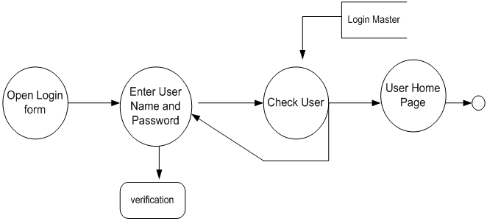

Figure 5.1 Login DFD Diagram

## 5.3 E-R DIAGRAM

**ER Diagram** stands for Entity Relationship Diagram, also known as ERD is a diagram that displays the relationship of entity sets stored in a database. In other words, ER diagrams help to explain the logical structure of databases. ER diagrams are created based on three basic concepts: entities, attributes and relationships.ER Diagrams contain different symbols that use rectangles to represent entities, ovals to define attributes and diamond shapes to represent relationships. At first look, an ER diagram looks very similar to the flowchart. However, ER Diagram includes many specialized symbols, and its meanings make this model unique. The purpose of ER Diagram is to represent the entity framework infrastructure.

* 1. E-R DIAGRAM

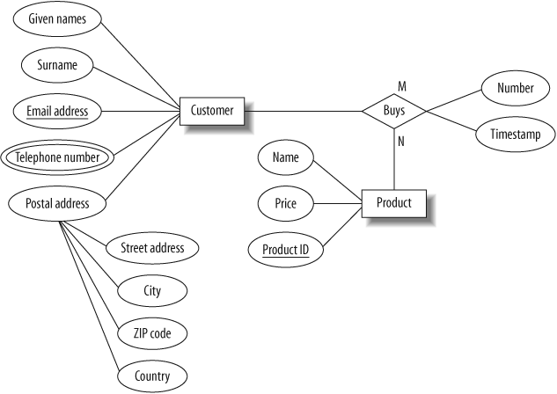

FIGURE 5.2 E-R DIAGRAM

# CHAPTER -6

**SYSTEM IMPLEMENTATION**

## 6.1 SCOPE

The scope of the "Step into Style" project encompasses various aspects related to the development, launch, and ongoing success of an innovative online footwear retail platform. Below is an outline of the project scope:

1. **E-commerce Platform Development:**
   * Design and develop a user-friendly and visually appealing e-commerce website for Step into Style, accommodating both desktop and mobile users.
2. **Brand Identity Establishment:**
   * Create a strong and distinct brand identity for Step into Style that resonates with the target audience, reflecting the essence of fashion, style, and comfort.
3. **Product Catalog Curation:**
   * Curate a diverse and trendsetting product catalog, ensuring a balance between the latest fashion trends, comfort, and quality across various types of footwear.
4. **Innovative Features Implementation:**
   * Incorporate innovative features, such as virtual try-on technologies, personalized recommendations, and interactive sizing guides, to enhance the overall shopping experience.
5. **User Authentication and Registration:**
   * Implement a secure user authentication and registration system to personalize user experiences and enable secure transactions.
6. **Secure Payment Gateway Integration:**
   * Integrate reliable and secure payment gateways to facilitate smooth and secure financial transactions for users.

By addressing these key areas within the defined scope, the "Step into Style" project aims to create a cutting-edge and customer-centric online footwear retail platform that provides a seamless and enjoyable shopping experience.

# CHAPTER -7

**RESULT**

## 7.1 BENEFITS

## The successful implementation and execution of the "Step into Style" project can yield several benefits, contributing to both business success and customer satisfaction. Here are some potential benefits your project can achieve:

## Increased Revenue:

## By offering a diverse and trendsetting product catalog with innovative features, you can attract a larger customer base, leading to increased sales and revenue.

## Strong Brand Presence:

## Establishing a strong and distinct brand identity can help create brand recognition and loyalty among customers, contributing to a lasting and positive presence in the market.

## Enhanced User Experience:

## The implementation of innovative features like virtual try-on and personalized recommendations can significantly enhance the overall user experience, attracting and retaining customers.

## Customer Loyalty and Retention:

## Features such as user profiles, order tracking, and personalized recommendations foster customer loyalty, encouraging repeat business and long-term relationships.

By achieving these benefits, the "Step into Style" project not only positions itself as a successful online footwear retailer but also establishes a foundation for sustainable growth and long-term success in the competitive e-commerce industry.

## 7.2 SCREENSHOTS

7.2.1 HOME PAGE

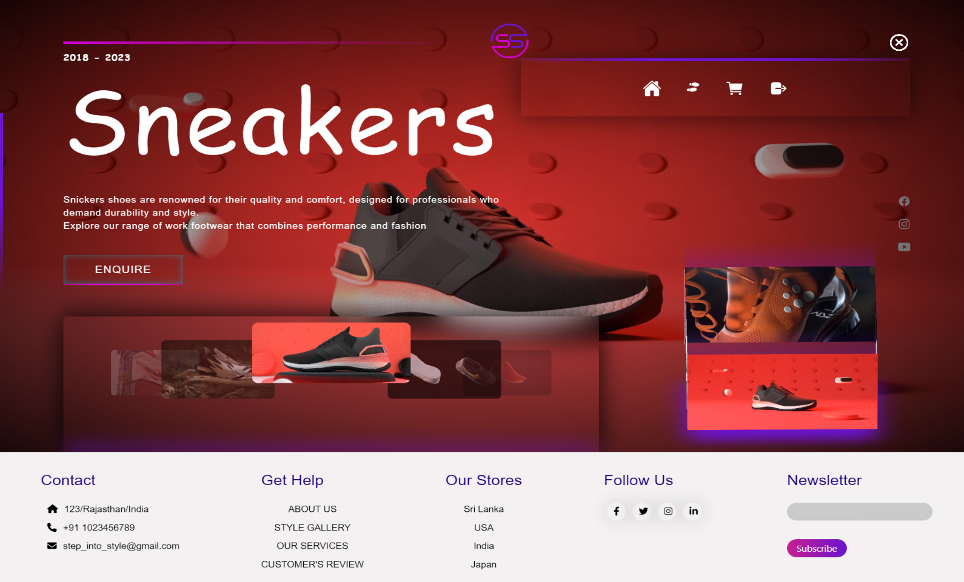

FIGURE 7.2.1 HOME PAGE

7.2.2 LOGIN PAGE

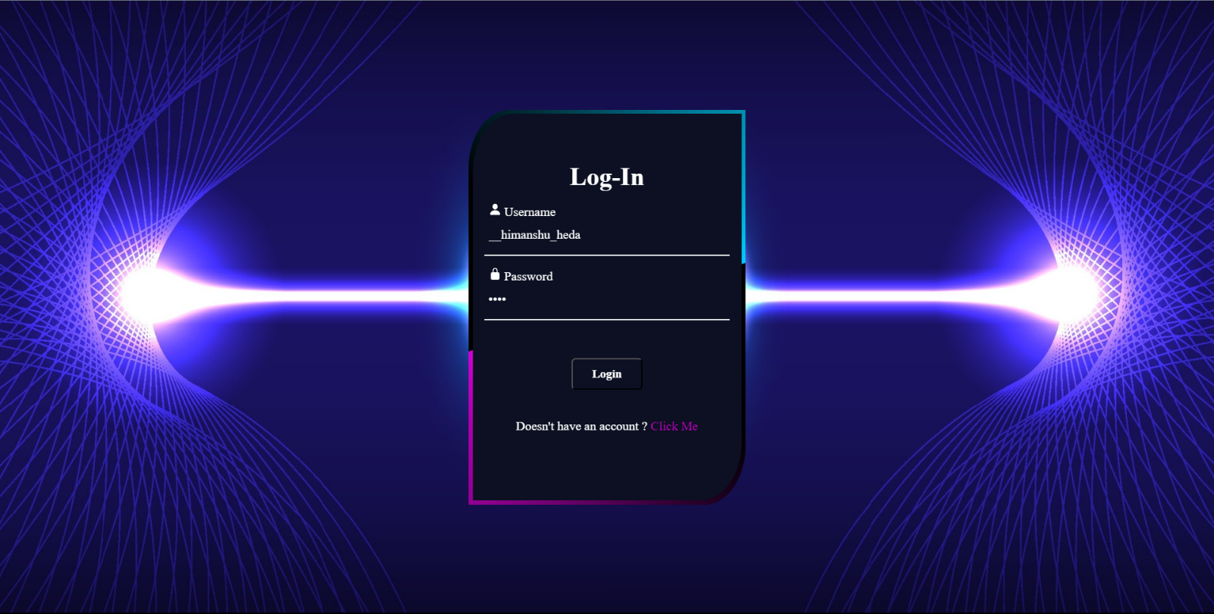

Figure 7.2.2 login pages

7.2.2 SIGNUP PAGE

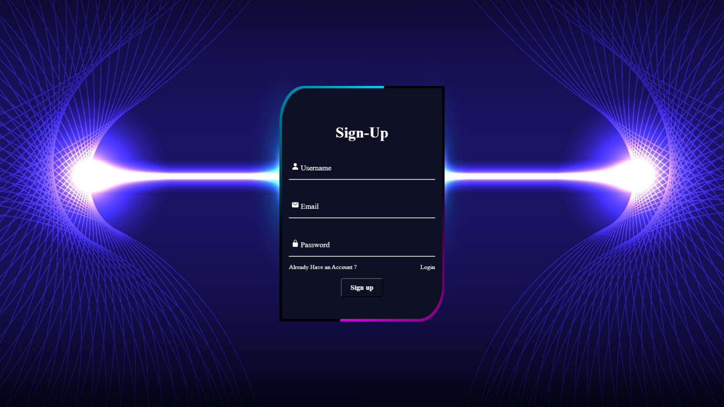

Figure 7.2.3 SignUp pages

7.2.3 ABOUTS US 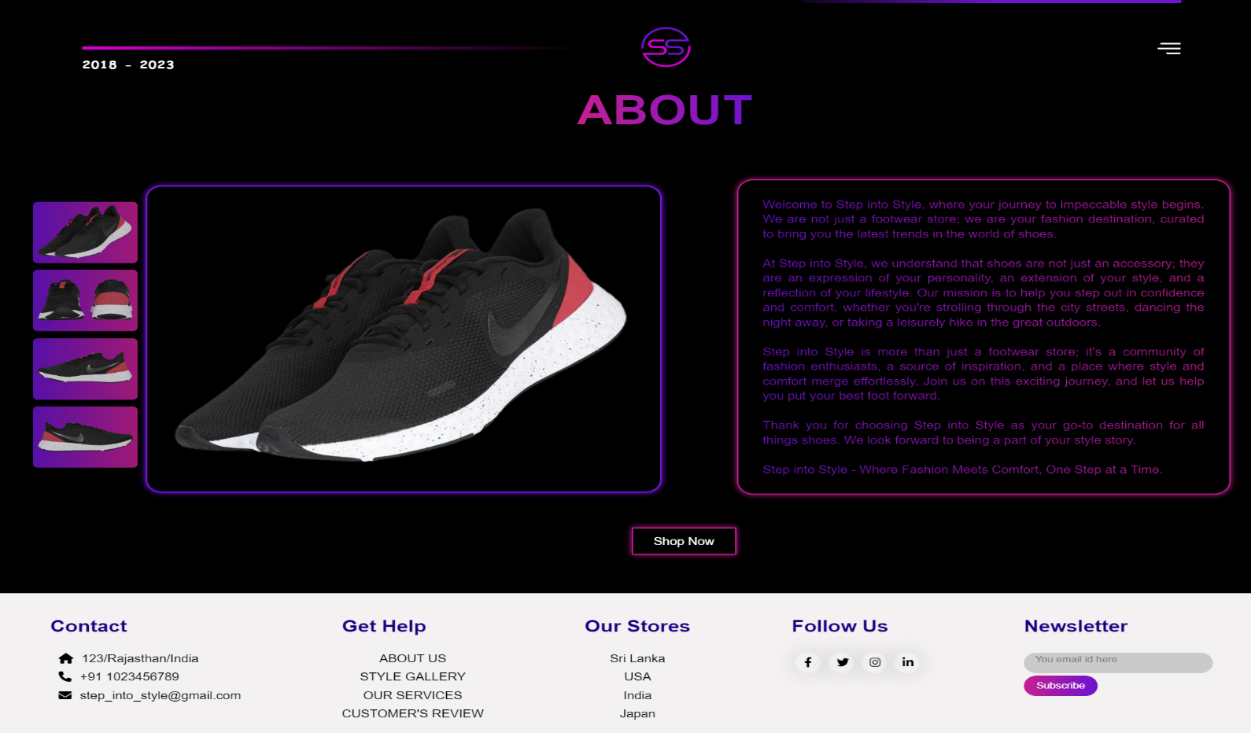

Figure 7.2.4 About us

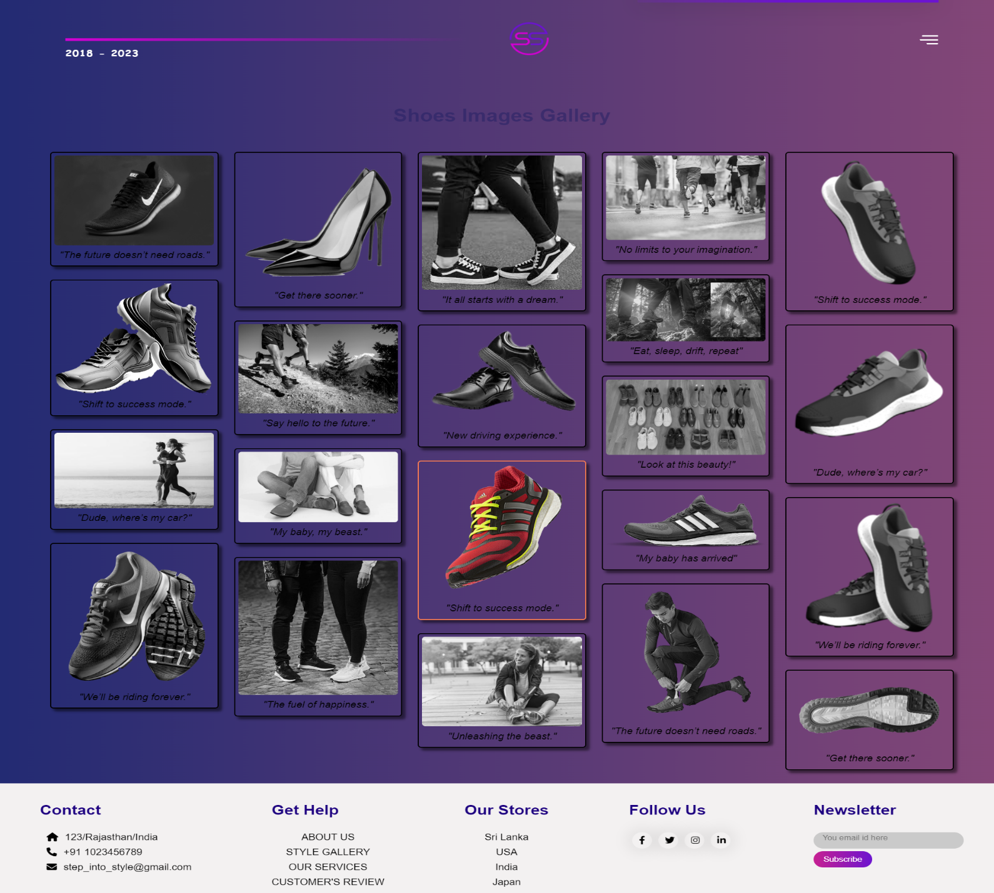7.2.5 GALLERY

Figure 7.2.5 GALLERY

7.2.6 OUR SERVICES

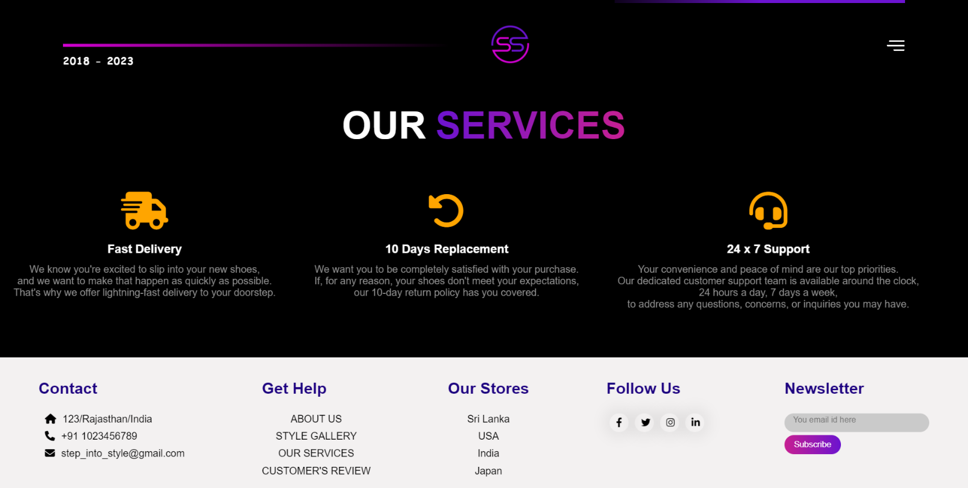

Figure 7.2.6 Our Services

7.2.7 CUSTOMER’S REVIEW

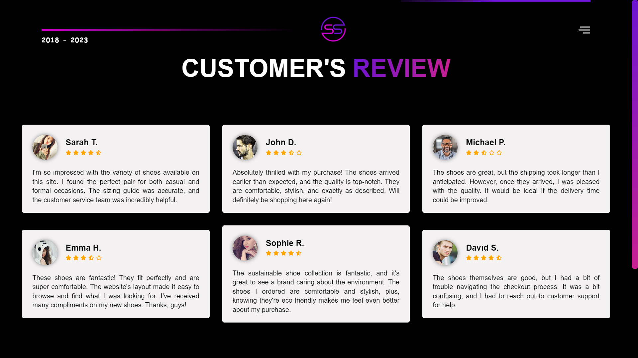

Figure 7.2.7 Customer’s Review

7.2.7 Footwear

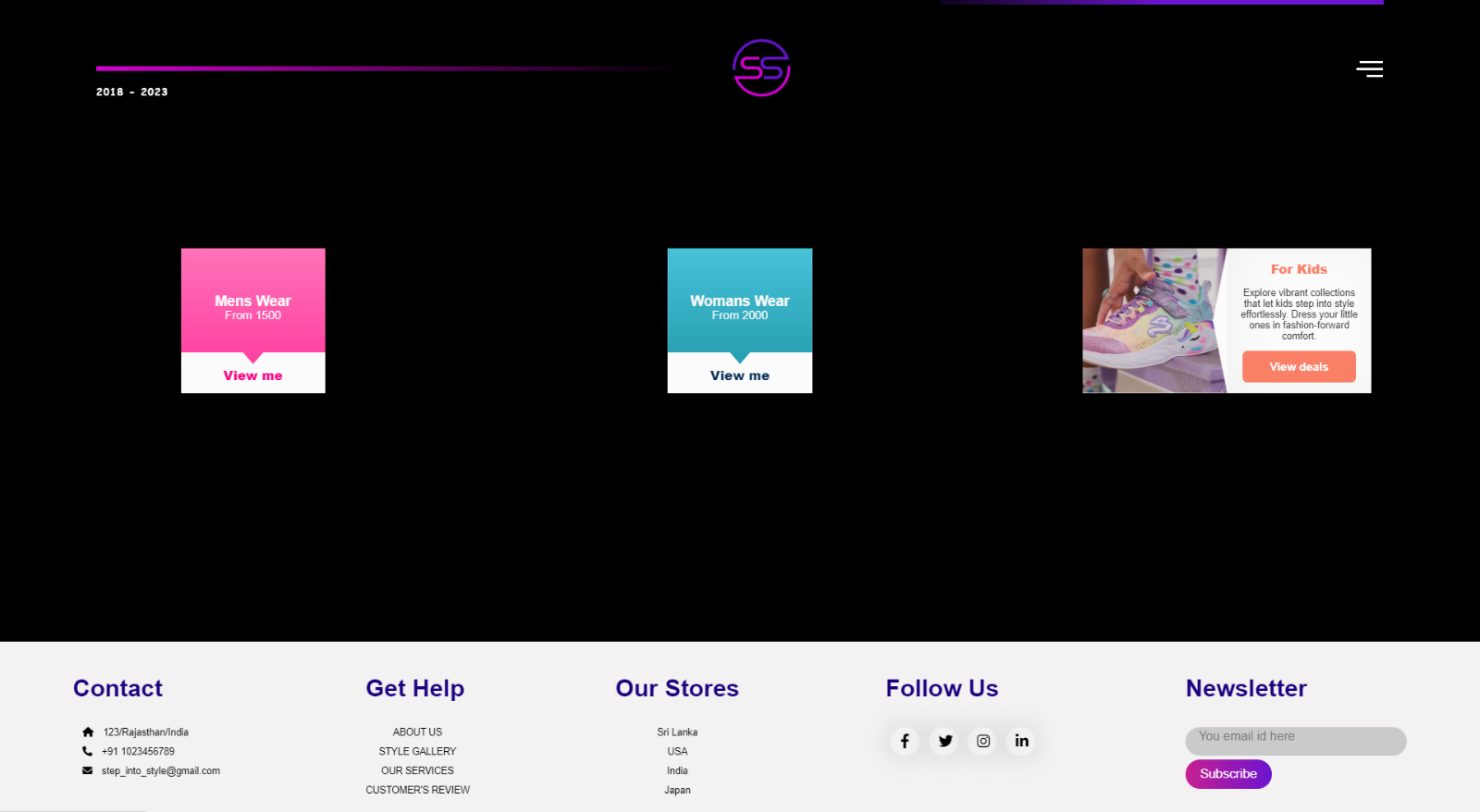

Figure 7.2.7 Footwear

7.2.9 Kids Wear

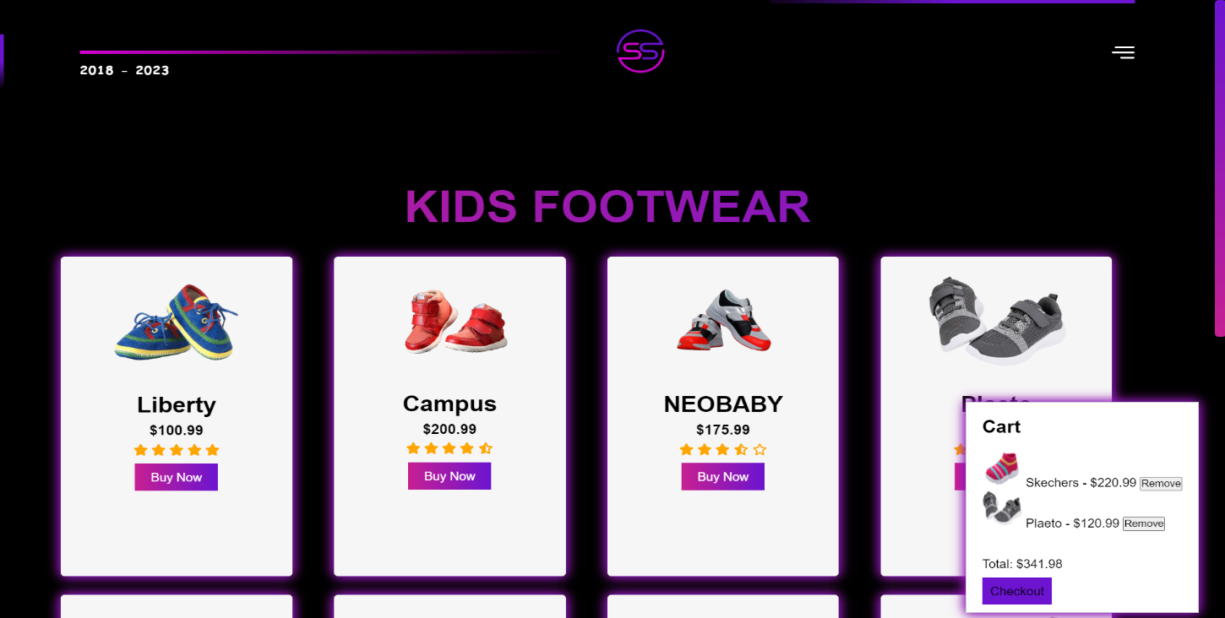

Figure 7.2.9 Kids Wear

7.2.10 Billing Details

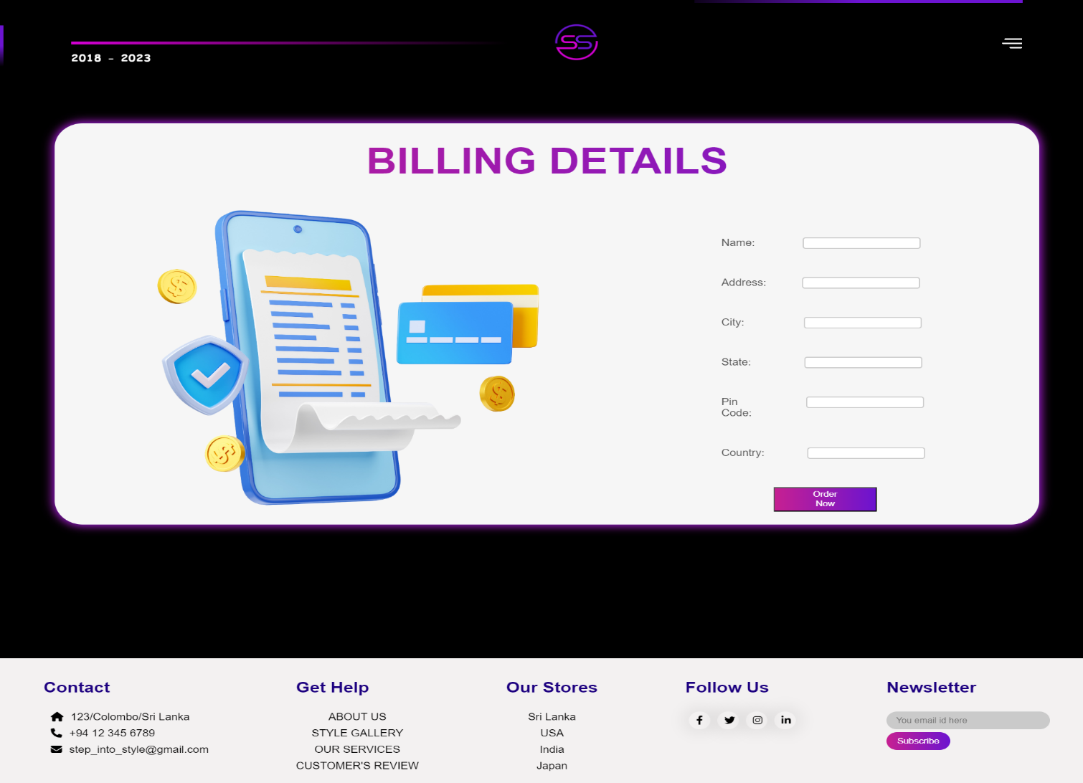

7.2.10 Billing Details

7.2.11 Table Structure of Database

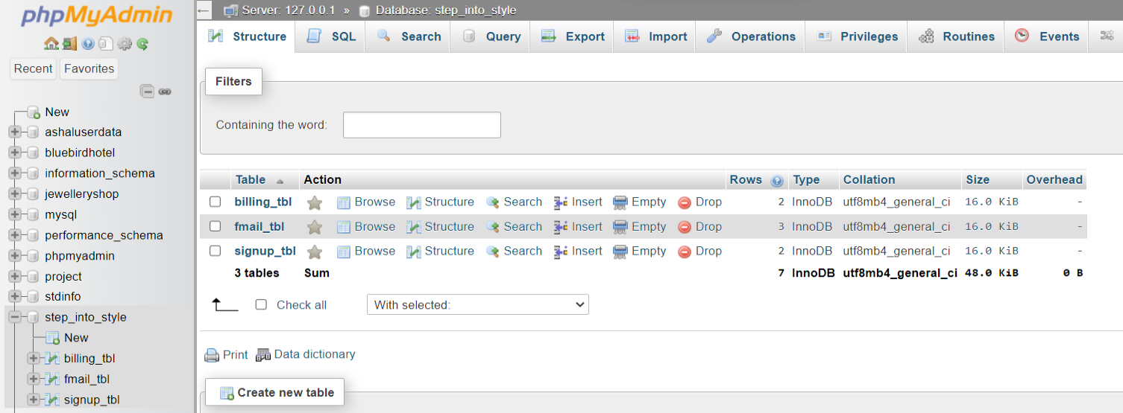

Figure 7.2.11 Table Structure of Database

Step Into Style –contains 3 MySQL tables

• billing_tbl

• fmail_tbl

• signup_tbl

7.2.3.1 billing_tbl MySQL Table

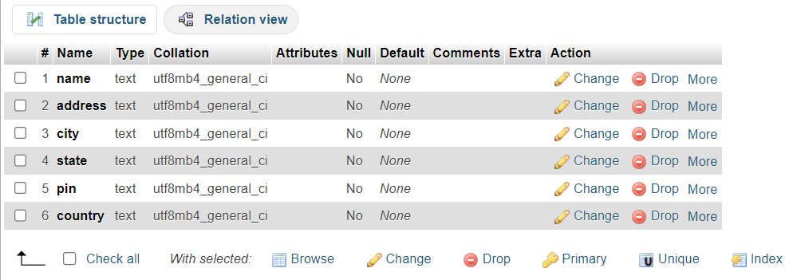

7.2.3.1 billing_tbl

7.2.3.2 fmail_tbl MySQL Table

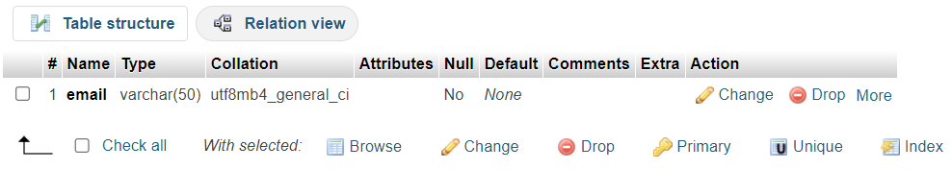

7.2.3.2 fmail_tbl

7.2.3.3 signup_tbl MySQL Table

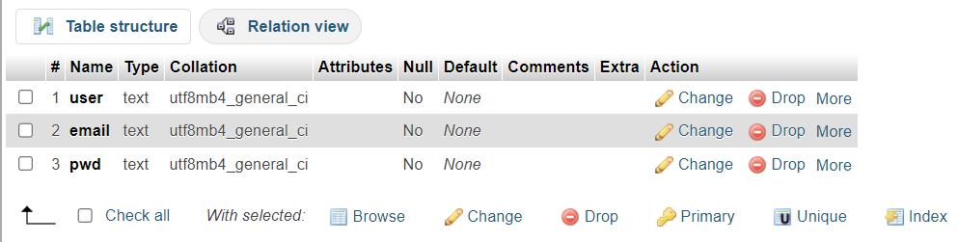

7.2.3.3 signup_tbl

# CONCLUSION

* In conclusion, the "Step into Style" project has been an exciting journey into the realm of online footwear retail, with the primary objective of creating a distinctive and customer-centric experience. Through meticulous planning, innovative design, and a commitment to excellence, the project has successfully laid the foundation for a premier destination for shoe enthusiasts.
* The establishment of a strong brand identity, coupled with a carefully curated product catalog, positions Step into Style as more than just an e-commerce platform; it becomes a style destination where fashion meets comfort. The incorporation of cutting-edge technologies, such as virtual try-on and personalized recommendations, adds a layer of sophistication and engagement to the user experience.
* Our emphasis on user-friendly design, responsive interfaces, and secure transactions ensures that the Step into Style website is not just a marketplace but a seamless journey for users from exploration to purchase. By integrating feedback mechanisms and continuously monitoring analytics, we are committed to staying attuned to the evolving needs and preferences of our valued customers.
* The strategic marketing initiatives, including social media campaigns and influencer partnerships, aim to elevate Step into Style's online presence and carve a niche in the competitive landscape. As the project concludes, we look forward to not only meeting but exceeding the expectations of our users, fostering loyalty, and becoming a go-to platform for those seeking the perfect blend of style and comfort.
* As we embark on the next phase of implementation and launch, the "Step into Style" project stands as a testament to the collaborative effort, creativity, and dedication of the team. We are excited about the prospect of contributing to the ever-evolving world of online fashion retail, and we are confident that Step into Style will leave an indelible mark in the hearts and closets of our customers.
* Step into Style – where every step is a statement, and style meets innovation. Thank you for accompanying us on this journey!

# FUTURE SCOPE

The future scope of the "Step into Style" project involves potential enhancements, expansions, and adaptations to stay relevant in the dynamic e-commerce landscape. Here are some areas of future scope for the project:

1. **Integration of Emerging Technologies:**
   * Explore and integrate emerging technologies such as augmented reality (AR) for virtual try-ons, artificial intelligence (AI) for advanced personalized recommendations, or blockchain for secure and transparent transactions.
2. **Enhanced Personalization:**
   * Implement more sophisticated algorithms for personalized user experiences, taking into account user preferences, buying behavior, and real-time trends to offer highly targeted product recommendations.
3. **Global Expansion:**
   * Consider expanding the platform's reach to international markets, accommodating diverse cultural preferences and adjusting the product catalog to cater to a broader audience.
4. **Inclusive Sizing and Accessibility:**
   * Enhance the website to be more inclusive by expanding size ranges and incorporating features to assist users with specific needs, such as accessibility options for individuals with disabilities.

By staying adaptable and responsive to industry trends and customer demands, the "Step into Style" project can continue to evolve and thrive in the competitive online footwear market. Regularly reassessing the business strategy and technology landscape will be crucial to identifying new opportunities for growth and improvement.

# REFERENCES

Here's a list of references, including books & websites that could provide valuable insights and information for "Step into Style":

**Websites:**

1. Sneaker News (sneakernews.com)
2. Highsnobiety (highsnobiety.com)
3. Hypebeast (hypebeast.com)

These references cover a range of topics from web usability and design principles to e-commerce strategies. Utilizing these resources can help you make informed decisions and create a successful and user-friendly "Step into Style" shoes website.